Week 6

1. ReactJS HOL

**Explain React components**

React components are the core building blocks of a React application. They represent parts of the UI and can be reused. Each component returns JSX, which is rendered as HTML in the browser.

**Identify the differences between components and JavaScript functions**

| **Aspect** | **React Components** | **JavaScript Functions** |
| --- | --- | --- |
| Purpose | Used to build and manage UI | Perform a specific task or logic |
| Return value | Returns JSX (UI) | Returns any value (number, string) |
| React-specific features | Can use state, props, hooks, lifecycle | Cannot use React features |
| Reusability in UI | Designed for reuse in UI structure | Not specifically for UI |

**Identify the types of components**

1. Class components
2. Function components

**Explain class component**

A class component is a component defined using a JavaScript class. It extends React.Component and must include a render() method that returns JSX. It supports state and lifecycle methods.

**Explain function component**

A function component is defined using a JavaScript function. It returns JSX directly and can use React Hooks to manage state and side effects.

**Define component constructor**

The constructor is a method in class components used to initialize state and bind event handlers. It’s called before the component is mounted.

**Define render() function**

The render() function is a required method in class components. It returns JSX which tells React what to display in the UI.

Steps:-

App creation:

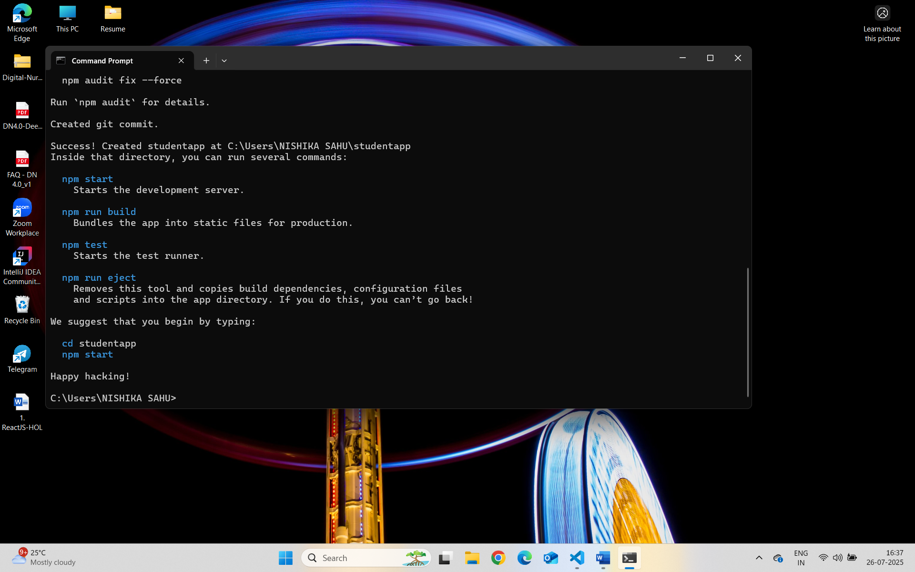

App.js:

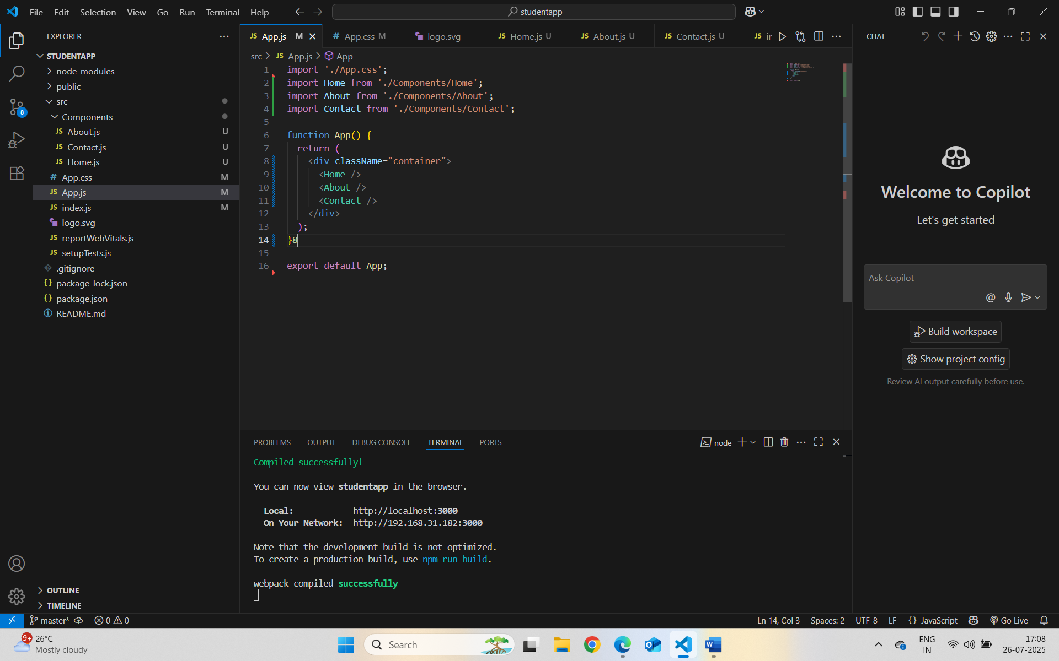

App.css:-

Home.js:-

About.js:-

Contact.js:-

Localhost:3000 :-

